Unity Assignment 2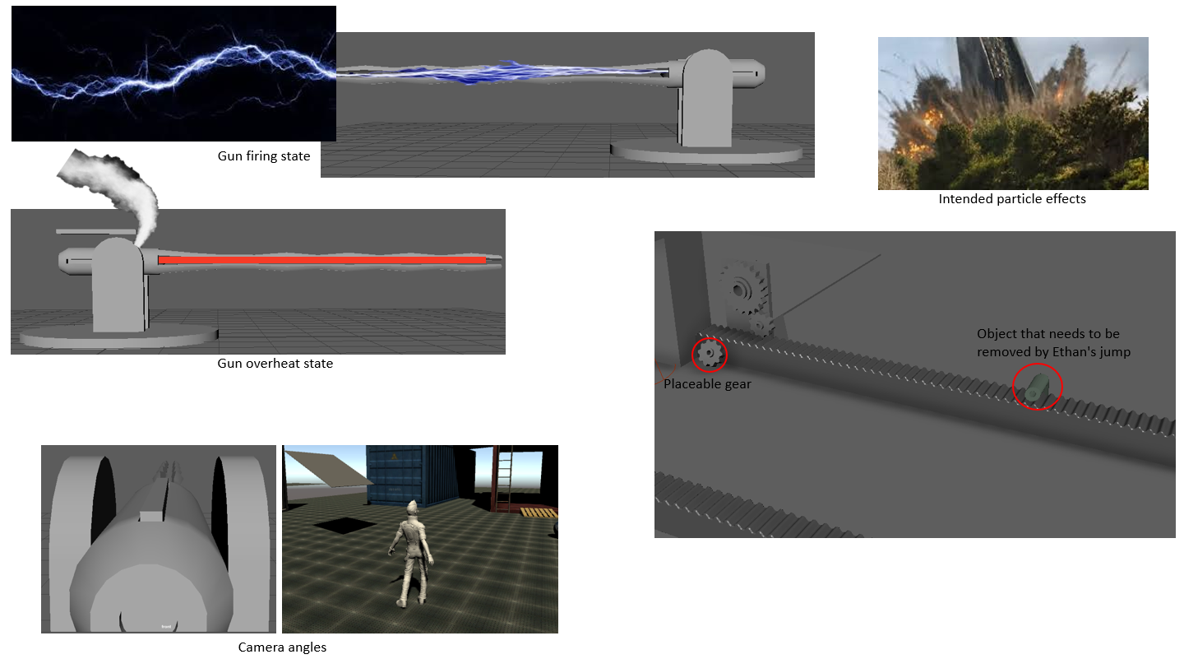

These are my initial ideas for how I want things to look, it shows the camera angles that I intend to use for Ethan and the gun, how the gun will look when fired and overheating some of the things that the user will be able to interact with and what particle effects will be used.

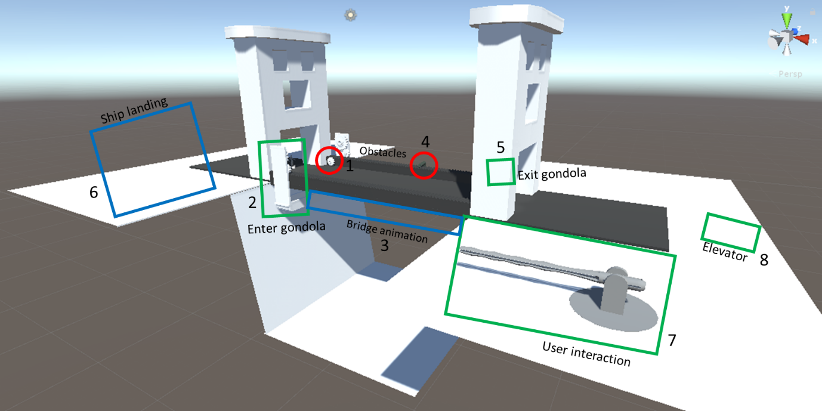

The image above is a breakdown of how I want the map to look like. It shows where I want things to take place and in which order things will happen.

Week 1 - Character Movement and Camera system

The character moves forward, left and right. Ethan can also run when shift and W are pressed to allow for quicker movement around the scene. An extremely basic camera system has been set up by making the main camera a child of Ethan so that it inherits his transformation and rotation.

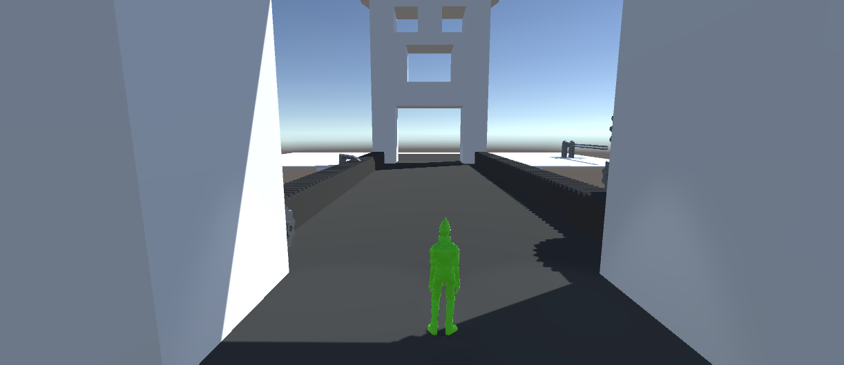

A few problems have arisen when trying to achieve this, one of these problems is that the character can often get stuck in animations. This is likely due to the fact that the character can only exit the animation from a single point. For example, if the character is running left, he must go through the walking animation before he can go into the idle state. To fix this problem, more transitions will be needed to compensate for this.

Another problem is that the very basic camera system doesn’t consider object occlusion. This is problematic as the camera can click into objects and see areas that aren’t meant to be seen by the player. To solve this, I will likely need to create a script for the camera so that this doesn’t happen and instead the camera goes no further than the objects.

Week 2 - Animation of scene

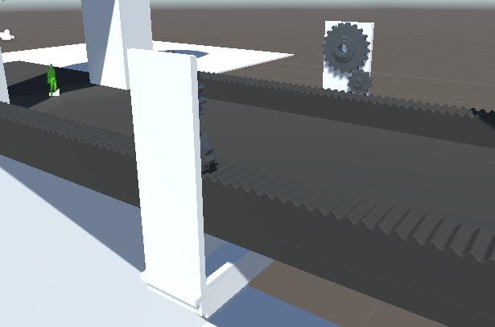

The scene now has animation with it, the gondola travels across the bridge with the gears turning.

The next step will be to add user interaction to start the animation so that it gives the user a chance to get into the gondola before it starts moving.

Week 3 - User interaction with scene

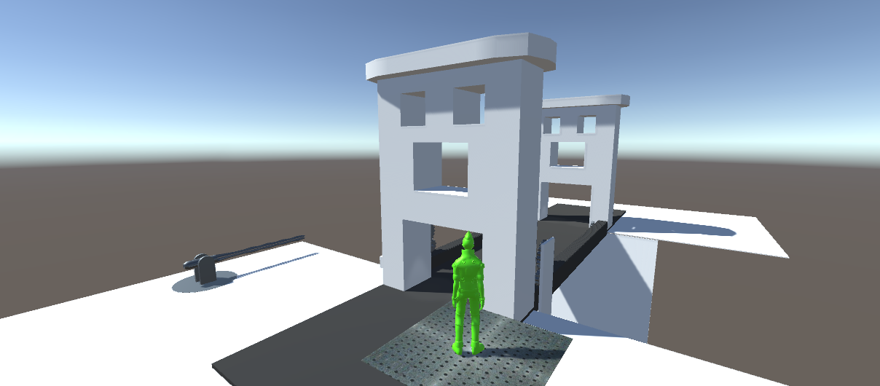

At this stage, the user can now use the elevator so that when Ethan stands on top of it, he is parented to the plane. The plane moves in two dimensions to demonstrate the parenting rather than the elevator working through simple gravity.

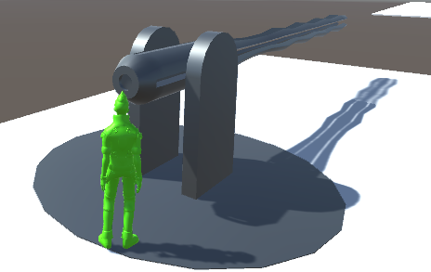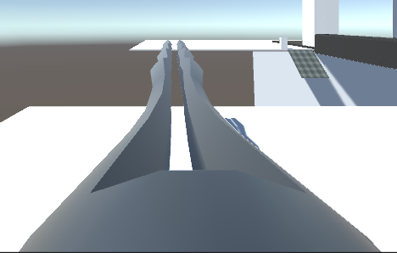

The user is also able to switch between the follow cam and the gun camera. This occurs when Ethan is within the designated hitbox and the user presses the ‘G’ key. To further this, I will need to remove the user’s ability to move Ethan so that he remains within the hitbox of the gun. Another thing that needs to be done is the controller for the gun so that when the user interacts with the gun, they are able to rotate and aim it.

Week 4 - Refinement of previous weeks work

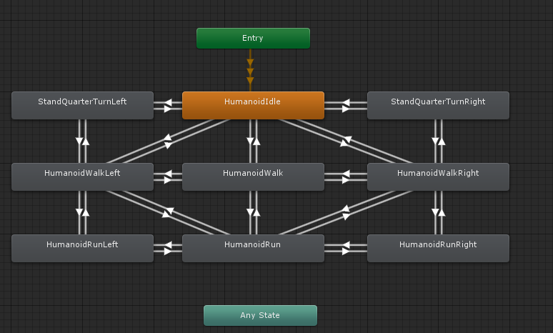

In an attempt to fix the problem of stuck animations, I have added more transitions between the states so that they have more exits.

My next step will be to add a movement script for the gun.

I have attempted to add user interaction between the user and one of the cogs so that they are able to pick it up and put it into place.

To solve occlusion, I will be adding a script that prevents this from happening by making sure that the position of the camera doesn’t surpass and objects collider